REPORT
OF
MERN STACK INTERNSHIP AT KODEMELON TECHNOLOGIES
Submitted To
Ms. Surabhi Purwar
School of Computer Science and Engineering
IILM University, Greater Noida, U.P.
In partial fulfilment of the requirement of degree of
B.Tech CSE

By
Roll Number of Student: CS-2341517
Name of Student: SHWETA YADAV

Batch: 2023–2027

CANDIDATE’S DECLARATION
I, SHWETA YADAV, do hereby declare that the internship report titled “MERN Stack Internship at KodeMelon Technologies — School ERP” has been completed by me to fulfil the requirement for the award of the degree of Bachelor of Technology in CSE. All the references have been quoted and I have not taken as such any material from any other source. I affirm that this report is my own and has not been submitted to any other institute for any degree/diploma requirement and further I shall be solely responsible for any kind of copyright violation in this regard.
Signature: __________________________
Student Name: SHWETA YADAV
Roll No.: CS-2341517

ACKNOWLEDGEMENT
I am using this opportunity to express my gratitude to everyone who supported me throughout the Internship Program. I am thankful for their aspiring guidance, invaluably constructive criticism and friendly advice during this work. I am sincerely grateful to them for sharing their truthful and illuminating views on a number of issues related to this work.
I express my gratitude to my parents for their blessings.
Signature: __________________________
Student Name: SHWETA YADAV
Roll No.: CS-2341517

TABLE OF CONTENTS

Chapter No. | Chapter Name | Page Nos.
 | Cover Page
1. | Candidate’s Declaration | i
2. | Acknowledgment | ii
3. | Table of content | iii
 | Internship Completion Certificate
4. | Project Description  4 .1 Introduction  4.2 Organization Profile  4.3 Problem Statement  4.4 Project Objectives  4.5 Scope of the Project  4.6 Technologies and Tools Used  4.7 System Architecture  4.8 Methodology  4.9 Expected Outcomes  4.10 Certificates of completion and other communication mail proof must be attached | 1  2  3  4  5  6  7  8 -9  9  10-11
5. | Bibliography/References | iv

INTERNSHIP COMPLETION CERTIFICATE
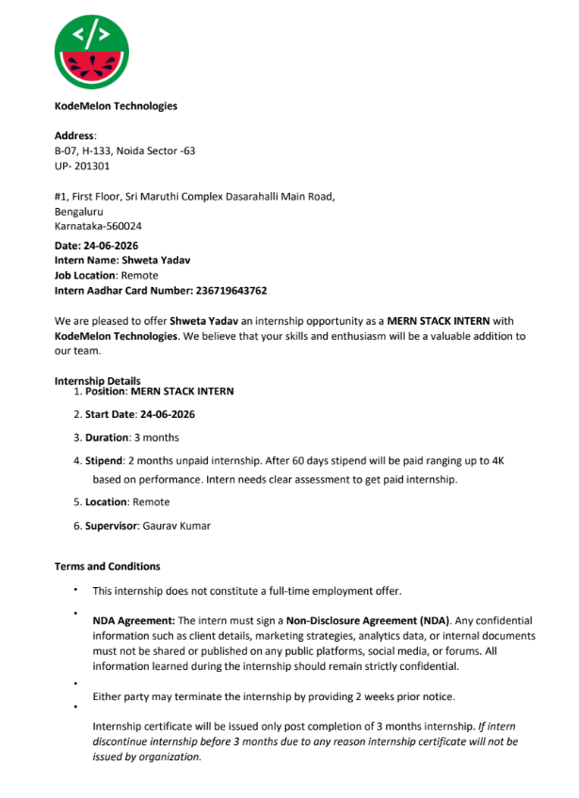

4. PROJECT DESCRIPTION

4.1 Introduction
The Summer Internship at KodeMelon Technologies provided practical exposure to MERN Stack development, software architecture, database design, REST API development, authentication, security, scalability, and AI-enabled applications. The internship was undertaken from 24 June 2026 to 24 September 2026 in the role of MERN Stack Intern. The internship was carried out in a remote work environment under the supervision of Gaurav Kumar.
During the internship, the major technical work focused on the research, planning, and technical documentation of a School ERP (Enterprise Resource Planning) system. The proposed School ERP was designed as a centralized platform to manage important academic and administrative activities such as student management, teacher management, attendance, fee management, homework, examinations, parent communication, notifications, and reports and analytics.
The technical work also covered system architecture, database design, REST API design, authentication, and security. The proposed architecture follows a Modular Monolithic Architecture, with JWT authentication, role-based access control (RBAC), bcrypt password hashing, and HTTPS encryption considered as key security measures.
In addition to the core application design, the internship provided exposure to performance optimization and scalable application design. Redis was planned for caching frequently accessed information such as dashboard statistics, student profiles, attendance reports, and fee summaries. The School ERP was also designed as a multi-school SaaS platform, using schoolId for data separation between schools. The technical documentation further included performance targets, load-balancing considerations, and scalable file storage using AWS S3.
The internship also included learning about AI-powered features for educational applications. The proposed School ERP incorporates concepts such as student performance analysis, personalized study plans, attendance prediction, an AI teacher assistant, an AI chatbot, and a parent insights dashboard. These features are intended to improve academic monitoring, provide personalized guidance, reduce repetitive work for teachers, and improve communication with students and parents.
As the internship is scheduled to be completed on 24 September 2026, the official internship completion certificate will be attached to the final report after completion. The internship offer letter specifies that the certificate is issued only after completion of the three-month internship.

4.2 Organization Profile
KodeMelon Technologies is the organization where I am undertaking my Summer Internship as a MERN Stack Intern. The internship provides practical exposure to full-stack web development, software architecture, database design, REST API development, authentication, security, scalability, and modern AI-enabled application features.
The organization provided an opportunity to understand how a modern MERN Stack application can be planned and structured. The documented technology stack includes React.js and Material UI for the frontend, Node.js and Express.js for the backend, MongoDB Atlas for database management, Redis for caching, and AWS S3 for file storage. Authentication and security were planned using JWT, bcrypt password hashing, role-based access control (RBAC), and HTTPS encryption.
The internship also provided exposure to system architecture, database relationships, REST API design, performance optimization, and scalable SaaS architecture. The proposed School ERP follows a Modular Monolithic Architecture and is designed to support multiple schools through schoolId-based data separation.
In addition, the internship work explored AI-powered features for the School ERP, including student performance analysis, personalized study plans, attendance prediction, an AI teacher assistant, an AI chatbot, and a parent insights dashboard. These features are intended to make the ERP more intelligent and useful for students, teachers, administrators, and parents.
Company Details
- Organization: KodeMelon Technologies
- Internship Role: MERN Stack Intern
- Internship Duration: 24 June 2026 – 24 September 2026
- Work Location: Remote
- Supervisor: Gaurav Kumar
- Internship Duration: 3 months

4.3 Problem Statement

Modern School ERP systems involve multiple modules, users, databases, APIs, and administrative activities. Without a centralized system, schools may face difficulties in managing student records, attendance, fees, homework, examinations, communication, and reports efficiently.
The project addressed these practical problems by proposing a centralized School ERP that brings major academic and administrative activities together. The system includes student management, teacher management, attendance, fee management, homework, examinations, parent communication, notifications, and reports and analytics.
Another challenge was designing a system that could remain secure, scalable, and maintainable as the number of users and schools increases. The proposed solution therefore includes a Modular Monolithic Architecture, JWT authentication, role-based access control, bcrypt password hashing, and HTTPS encryption.
The project also required proper database and API design for managing school, user, student, attendance, fee, and homework information. REST APIs were defined for authentication, student management, attendance, homework, and fee-related operations to support communication between the frontend and backend.
A further challenge involved performance and scalability. Redis caching was planned for frequently accessed data such as dashboard statistics, student profiles, attendance reports, and fee summaries. The system was also designed as a multi-school SaaS platform using schoolId for data separation between schools.
Finally, the project explored AI-powered features such as student performance analysis, personalized study plans, attendance prediction, an AI teacher assistant, an AI chatbot, and a parent insights dashboard to make the School ERP more intelligent and useful.

4.4 Project Objectives
The primary objectives of the internship were:
- To gain practical experience in MERN Stack development and full-stack software development practices.
- To understand and design a School ERP system using React.js, Node.js, Express.js, and MongoDB.
- To understand and design modules for student, teacher, attendance, fee, homework, examination, and communication management.
- To design a structured database architecture using MongoDB for storing and managing school-related information.
- To understand and design REST APIs for authentication, student management, attendance, homework, and fee operations.
- To implement and understand authentication and security practices using JWT, RBAC, bcrypt password hashing, and HTTPS.
- To understand caching and performance optimization using Redis for frequently accessed ERP data.
- To design a scalable multi-school SaaS architecture using school-based data separation and load-balancing concepts.
- To gain practical exposure to AI-powered features such as student performance analysis, attendance prediction, personalized study plans, and AI chatbots.
- To improve technical documentation, problem-solving, system-design, and professional software development skills through the development and documentation of the School ERP solution.

4.5 Scope of the Project

The scope of the internship covered MERN Stack development, School ERP system design, database management, API development, security, scalability, and AI-related application features.
The technical scope included React.js, Material UI, Node.js, Express.js, MongoDB Atlas, Redis, AWS S3, JWT authentication, bcrypt password hashing, REST APIs, role-based access control, and system architecture design. The work also covered database design, API documentation, security practices, caching, performance optimization, and multi-school SaaS architecture.
The School ERP project extended the scope to multiple modules, including student management, teacher management, attendance management, fee management, homework management, examination management, parent communication, notifications, and reports and analytics. The system was designed to provide a centralized platform for managing school activities efficiently.
The project also included the study of scalability and performance, including Redis caching, multi-school data separation using schoolId, load balancing, and defined performance targets. These concepts were considered to make the proposed ERP suitable for supporting multiple schools and a growing number of users.
The internship also provided exposure to AI-powered educational features, including student performance analysis, personalized study plans, attendance prediction, an AI teacher assistant, an AI chatbot, and a parent insights dashboard.

4.6 Technologies and Tools Used
- JavaScript – Used for application development and implementing functionality within the MERN Stack environment.
- React.js – Used for developing the frontend interface of the proposed School ERP system.
- Material UI – Used for creating a structured, responsive, and user-friendly interface for the ERP application.
- Node.js – Used for developing the backend services and server-side application logic.
- Express.js – Used for building REST APIs and handling backend requests and responses.
- MongoDB Atlas – Used as the primary database for storing and managing school-related data.
- Redis – Used for caching frequently accessed data such as dashboard statistics, student profiles, attendance reports, and fee summaries.
- AWS S3 – Considered for secure storage and management of application files and documents.
- JWT (JSON Web Token) – Used for implementing secure authentication and maintaining user sessions.
- bcrypt – Used for securely hashing and protecting user passwords.
- REST APIs – Used for communication between the frontend and backend for modules such as authentication, students, attendance, homework, and fees.
- Role-Based Access Control (RBAC) – Used to manage permissions for different users such as Admin, Teacher, Student, and Parent.
- Git and GitHub – Used for source-code management, version control, collaboration, and maintaining project changes.
- HTTPS and Security Practices – Considered for securing communication and protecting sensitive application data.
- AI-Based Tools and Features – The project included research into AI-powered capabilities such as student performance analysis, personalized study plans, attendance prediction, AI teacher assistance, AI chatbot functionality, and parent insights.

4.7 System Architecture
The School ERP system was designed as a modular monolithic architecture using the MERN Stack. The architecture was planned to keep major ERP functions organized as separate modules while allowing them to operate within a unified application. The proposed technology stack included React.js and Material UI for the frontend, Node.js and Express.js for backend services, and MongoDB Atlas for data management.
At the application layer, the frontend communicates with the backend through REST APIs. The backend manages authentication, student records, attendance, homework, fees, and other ERP operations, while MongoDB stores the related school data. JWT-based authentication and role-based access control were considered for securing access according to user roles such as Admin, Teacher, Student, and Parent.
A simplified logical architecture is:
User / Staff / Student / Parent
↓
React.js + Material UI Frontend
↓
Node.js + Express.js Backend / REST APIs
↓
MongoDB Atlas Database
↓
Redis Cache / AWS S3 Storage
The proposed system also included Redis caching for frequently accessed information such as dashboard statistics, student profiles, attendance reports, and fee summaries. Multi-school support was planned using schoolId-based data separation, allowing the same ERP platform to support multiple schools while maintaining logical data isolation.
The School ERP project covered multiple integrated modules, including Student Management, Teacher Management, Attendance Management, Fee Management, Homework Management, Examination Management, Parent Communication, Notifications, and Reports and Analytics. These modules were designed to provide a centralized platform for managing academic and administrative activities.

4.8 Methodology
The internship followed a practical, task-oriented engineering methodology.
4.8.1 Content Pilot – Postiz The work began with understanding the existing application and its frontend structure. Frontend changes were implemented using TypeScript and JavaScript. Docker was used to run the project consistently. External platform connections were handled using the required API keys and integrations. The workflow supported connecting social platforms including Instagram, Facebook, Twitter/X, and Pinterest, with the objective of allowing centralized scheduling and publishing.
4.8.2 Enterprise AI Workspace The development environment was first standardized through Docker Compose. Services included frontend, backend, PostgreSQL, ChromaDB, and Ollama. Environment files were separated for example, development, and production use. A bootstrap script was planned/implemented to reduce setup effort for new developers.
A GitHub Actions CI workflow was created to run on pull requests. The pipeline installed dependencies, built the frontend and backend, ran linting, and verified Docker image builds. Nginx was configured as a reverse proxy so frontend traffic and API traffic could be routed appropriately.
Health checks were implemented/documented for the major services. Logging infrastructure was organized around centralized Docker logs, log directories, and rotating log files. Development documentation was structured into setup, Docker, Git workflow, branching, and deployment guides. A Makefile/task runner provided common commands such as up, down, logs, build, restart, and clean.
GitHub/GitLab standards were also addressed through branch naming, pull-request and issue templates, optional CODEOWNERS, branch protection, labels, and milestones. Repositories associated with project members were handled on GitLab, and pipelines were checked for successful execution. When failures or bugs appeared, the issues were investigated and resolved as part of the development workflow.
4.8.3 Lead Generation and Client Outreach Potential client companies were researched based on the possibility that SystemaOps could provide Odoo automation, DevOps automation, AI adoption, or related technology services. Relevant company information and potential opportunities were identified. Outreach messages were sent through LinkedIn and email. When a prospect showed potential, the lead was communicated to the owner for further engagement.
4.8.4 Generative AI Learning Generative AI tools, particularly ChatGPT and Gemini, were used to learn AI-assisted video creation and content-generation workflows. This provided practical exposure to prompting, content development, refinement, and AI-assisted production.

4.9 Expected Outcomes
The internship was expected to develop both technical and professional competencies. The major outcomes include:
- Practical understanding of Docker-based development and multi-service environments. • Experience with CI/CD concepts and automated validation through GitHub Actions.
- Better understanding of environment configuration and deployment-related practices.
- Experience with Nginx reverse proxy configuration and service health monitoring.
- Exposure to centralized logging and troubleshooting.
- Improved Git, GitHub, and GitLab collaboration and pipeline debugging skills.
- Practical frontend development experience using TypeScript and JavaScript.
- Understanding of API-based social-media platform integration and centralized scheduling.
- Exposure to enterprise AI workspace architecture and AI infrastructure components.
- Improved technical documentation and developer onboarding practices.
- Experience with professional lead generation, client research, email communication, and LinkedIn outreach.
- Practical familiarity with generative AI tools for video and content creation.

4.10 Certificates of Completion and Communication Proof
The Internship Completion Certificate issued by SystemaOps is attached as supporting evidence of the internship. The certificate recognizes Eshika Mathur for successfully completing a three-month Cloud & DevOps Engineering Internship at SystemaOps.
The certificate is signed by the authorized signatory and HR department of SystemaOps. The offer letter is also retained as supporting documentation of the internship engagement. Additional relevant communication – offer letter, certificate

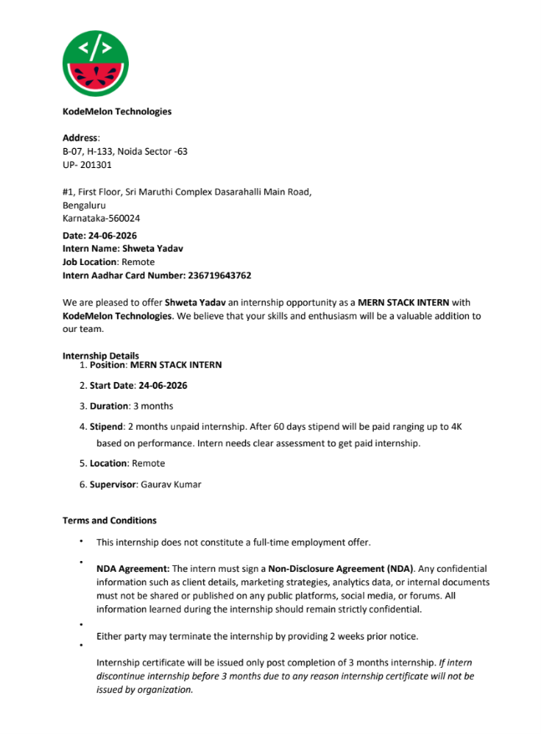
5. BIBLIOGRAPHY / REFERENCES
- KodeMelon Technologies, “School ERP Research & Technical Documentation.”
- KodeMelon Technologies, Internship Offer Letter, dated 24 June 2026.
- IILM University, School of Computer Science and Engineering, “Internship Report Format updated 26-27.”
- MongoDB, “MongoDB Atlas Documentation.”
- React.js, “React Documentation.”
- Node.js, “Node.js Documentation.”
- Express.js, “Express.js Documentation.”
- Redis, “Redis Documentation.”
- Amazon Web Services, “Amazon S3 Documentation.”
- OpenAI, “ChatGPT,” used for AI-assisted learning, research, and development-related tasks.

